Design and Analysis of Algorithms

Practice Final Exam

NAME _____________________________

- [Dynamic programming 25%]
  - Apply dynamic programming to algorithm X [10%]
  - Given the recurrence equation for Y write pseudo code for a recursive and memoized algorithm that solves the problem [15%]

- [Greedy 25%]
  - Modify Dijkstra’s shortest path algorithm as follows: the algorithm will now store in P the parent of every node added to the solution (except s). [5%]

Dijkstra:
1 for each u ∈V
2. do D [u ] ← ∞
3. D[ s ] ← 0
4. //initialize P
6. PQ ←make-PQ(D,V)
7. while PQ ≠ ∅ do
8. u ← PQ.extractMin()
10. for each v ∈ Adjacent (u )
11. do if v ∈PQ && w( u, v )+D[u] < D [ v ]
12. then D [ v ] ← w (u, v) +D[u]
13. PQ.decreasePriorityValue( D[v], v)
14. return P

  - Write pseudo code for a procedure that takes P and prints the path from s to t. [10%]

  - Describe a greedy algorithm for the 0/1 knapsack problem with fractions. [10%]

- [NPC 20%]
An independent set of a graph G=(V, E) is a subset V' ⊆ V such that no two vertices in V' are connected by an edge. (An alternative definition is that each edge in E is incident on at most one vertex in V'). [20%]

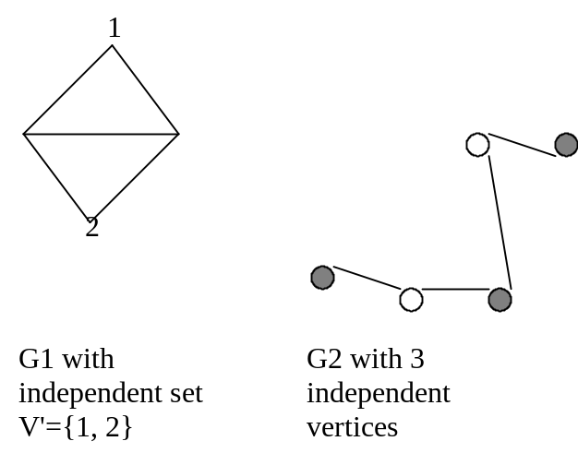
The maximum independent set problem is: Given graph G, find the size of the maximum size independent set in G.

  - Convert the maximum independent set problem into a decision problem. [3%]

  - Show that the decision problem is in NP. [7%]

  - Draw the four possibilities of the relationships between P, NP and co-NP. [10%]

- [Network flow 30%]
  - What is the worst case time complexity of the Ford and Fulkerson algorithm? [5%]

O(E*MF) MF is maximum flow.
Considering worst case scenario, for each iteration only 1 unit of flow is added. Hence running time is based not only on problem size but also on capacity of edges thus large edges will take longer time.

  - When Ford and Fulkerson is used for solving the matching problem its time worst case complexity is O(VE). Explain why. [5%]

Slide 37,38,39

  - Find the maximum flow for the network below. [5%]

12
b

15 7
a
c
d
s
t

3 5
4 10

10

  - What is the min-cut for the network? Which vertices are in S and which are in T? [5%]

  - Prove that when the flow is maximized there are no augmenting paths in the residual network [10%].

DO check slides 30,31,32 may be 31 or 32 can be asked.

- [Disjoint data set]
Given a disjoint data set with elements 1, 2, 3, 4, 5 6 and 7. Currently there are three sets: {1,3,4,7}, {2,5} and {6} and the array contains 1, 2, 1, 1, 2, 6, 4. Assume that the two heuristics are used.
  - Show the backward tree representation of the sets.

  - Give the backward tree after the two sets {1, 3, 4, 7} and {2, 5} are merged into a single set

  - Give the array that represent the new graph produced in c)

  - Show the compressed tree after find(5) is executed.

